Elton, Gruber, Brown, and Goetzmann
Modern Portfolio Theory and Investment Analysis, 9th Edition
Solutions to Text Problems: Chapter 22

Chapter 22: Problem 1

The duration formula shown in the text for annual payments can easily be modified to reflect semi-annual payments as follows:

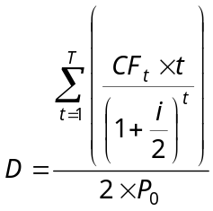

where T is the number of semi-annual periods remaining to maturity.

Given P₀ = $1,000, semi-annual interest payments of $50, a principal of $1,000 paid at the end of 5 years and a flat yield curve at 10%, we have:

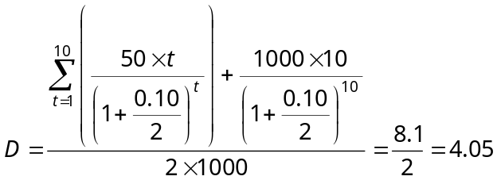 years.

Chapter 22: Problem 2

The duration formula for annual payments annual payments is:

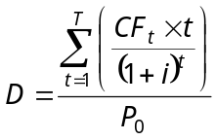

where T is the number of years remaining to maturity.

Given P₀ = $1,000, annual interest payments of $100, a principal of $1,000 paid at maturity and a flat yield curve at 10%, we have:

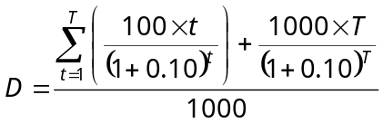

where T has values of 10, 8, 5 and 3 years.

Using the above equation, we have:

T |  |  | D
 | 10 |  |  |  | 6.76
 | 8 |  |  |  | 5.87
 | 5 |  |  |  | 4.17
 | 3 |  |  |  | 2.74

Chapter 22: Problem 3

Let X_{A} be the portfolio’s investment weight for bond A, X_{B} be the portfolio’s investment weight for bond B, and, since an investment portfolio’s weights sum to 1, X_{C} = (1 − X_{A} − X_{B}) be the portfolio’s investment weight for bond C. Given the individual bonds’ durations, the duration of a portfolio of those bonds is:

D_{P} = 5X_{A} + 10X_{B} + 12(1 − X_{A} − X_{B})

Setting the portfolio’s duration equal to the target duration of 9, we have:

5X_{A} + 10X_{B} + 12(1 − X_{A} − X_{B}) = 9

Since there is just one equation with two unknowns, there are an infinite number of solutions (portfolios) that will satisfy the equation. Either X_{A} or X_{B} can be arbitrarily set and then the remaining weights solved for. Three of the infinite number of solutions are:

1.) X_{A} = 22/56; X_{B} = 7/56; X_{C} = 27/56

2.) X_{A} = 4/14; X_{B} = 7/14; X_{C} = 3/14

3.) X_{A} = 10/28; X_{B} = 7/28; X_{C} = 11/28

Chapter 22: Problem 4

Since in this problem there are three bonds with three sets of cash flows to meet the three liabilities, we have three equations with three unknowns and therefore one unique solution. In a more realistic situation, there would be many more bonds than the number of liabilities (many more unknowns than the number of equations) and thus there would be an infinite number of solutions. In that case, the linear programming procedure shown in the text’s Appendix B would be required to find the least-cost solution.

Let Y_{A} be the fraction of A bonds to buy, Y_{B} be the fraction of B bonds to buy, and Y_{C} be the fraction of C bonds to buy. (Note that these are not investment weights that sum to 1.) We want to form a portfolio of these three bonds that replicates the timing and amounts of the liabilities.

At t = 1: $50 Y_{A} + $100 Y_{B} + $1,000 Y_{C} = $250

At t = 2: $1,050 Y_{A} + $100 Y_{B} + $0 Y_{C} = $500

At t = 3: $0 Y_{A} + $1,100 Y_{B} + $0 Y_{C} = $550

The solution to the above set of simultaneous linear equations is:

Y_{A} = 9/21; Y_{B} = 1/2; Y_{C} = 15/84

Assuming fractional purchases may be made, the cost of the bond portfolio is then:

Y_{A} P_{A} + Y_{B} P_{B} + Y_{C} P_{C} = 9/21 × $950 + 1/2 × $1,000 + 15/84 × $920 = $1,071.43

Chapter 22: Problem 5

Equation (21.6) in the text is a form of a single-index model for bonds:

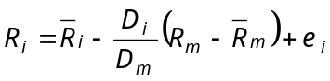

If the yield curve is flat at 10%, then the first period’s expected return is 10% for each of the three bonds. Since the market portfolio is a weighted average of the three bonds, the market portfolio also has an expected return of 10%. The duration of the market portfolio is a weighted average of the three bonds’ durations. Since the three bonds are assumed to be of equal value, the value-weighted market portfolio is also an equally weighted portfolio. Therefore, the duration of the market portfolio is:

D_{m} = 1/3 × 5 + 1/3 × 10 +1/3 × 12 = 9 years

Therefore we have:

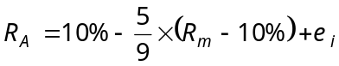

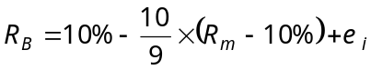

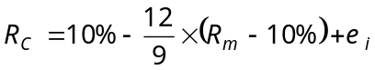

We have seen in an earlier chapter that, under the assumptions of the Sharpe single-index model, the covariance between the returns on any pair of securities i and j is:
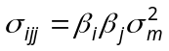

Making the same assumptions as those for the Sharpe single-index model and recognizing that 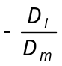 in the bond single-index model (equation (21.6)) is analogous to β_{i} in the Sharpe single-index model, the covariance between the returns on any pair of bonds i and j is:

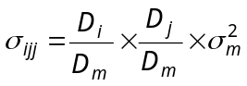
Therefore we have:

